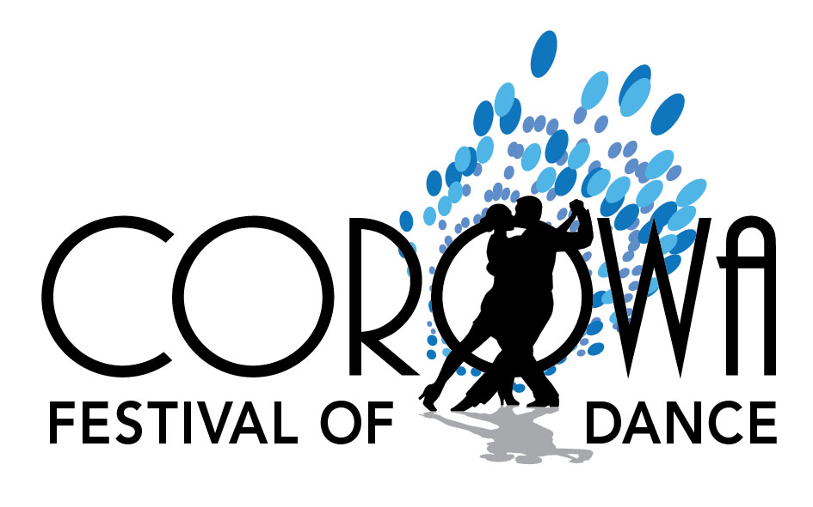
Corowa Festival of Dance:- Dances Selected from:
Foxtrot
Charmaine
Alpha MW
Evening 3 Step
Tracey Leigh
Red Rose Saunter
Sally Ann Cha Cha
Tangoette
Carousel
Monte Carlo
Emmerdale
Festival Glide
Dynasty Blues
La Bomba
Louisa
Queen of Hearts Rumba
Midnight Tango
Serenade W
Cindy Swing
New Vogue MW
Alpine Stroll
Barclay Blues
JAB Samba
Lucille W
Balmoral Blues
Swing Waltz
Melba Blues
Mayfair QS
Anna-Lisa Waltz
Merrilyn
Excelsior Schotiche
Twilight Waltz
Celebrity Saunter
Killarney W / V
Tango Terrific
Presentation W
Glenroy Foxtrot
Woodside MW
Banyan Blues
Parma Waltz
Silver Rumba
Chicago Swing
Jive
Pride of Erin
Empress Waltz
Gypsy Tap
Presidents Daughter’s W
Dance Magic Rumba
Tango 44
Catherine MW
Midnight Jive
New Vogue QS
El Tel Cha Cha
Miami Rumba
Brekken QS
Fitzon QS
LaPaTony
Saga
Mississippi Blues
Workshop Dance

